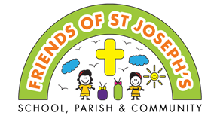
You and your grown-up are invited to our
Reception Christmas Tea Party on
Sunday 1st December 3-5pm in the school hall.
Come and enjoy afternoon tea, crafts and games while you wait to see Santa for a special gift, as well as a bag of treats. We hope that you can come.
From
Friends of St. Joseph’s

This is a time to meet other parents and children in reception, so we are asking that siblings do not come, so that you can spend this special time with your child. All children must be accompanied by an adult. We hope you understand this and thank you for your support.

If you would like your child to attend please complete the booking form below and return it with £5 in an envelope clearly named ‘Friends Christmas Tea Party’ to the Friends postbox next to the office by
Friday 22nd November.
Reception Christmas Tea Party & Santa’s grotto

----------------------------------------------------------------------------------
Reception Christmas Tea Party & Santa’s grotto
Child’s name: | Reception Pear Oak
Any specific dietary requirements | I have enclosed £5
Parent/Guardian Signature

Only the reception child named above will receive a gift from Santa.
Thank you

