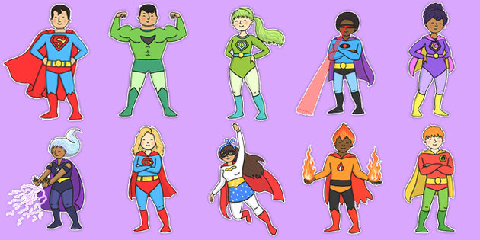

# Year 4 Pear & Oak

**General Reminders…**

* Please ensure all children have appropriate clothing for woodland warriors in school. We will have Woodland Warriors on Tuesday afternoons – children will need their own wellies as spares are very limited. If they do not have wellies then they might not be allowed to go to Woodland Warriors.

**PE in Year 4**

PE kits need to be kept in school at all times as children never know when we might need them. Please make sure that PE kit is clearly labelled with the child’s name. We will try to be outside for PE as much as possible therefore children would benefit from the winter PE uniform of plain, dark joggers and top. Children can wear their jumper or cardigan if needed. Trainers not pumps please.

If children wear ear rings they need to cover these with tape for each lesson. Tape is not provided; children will need to bring it with them.

If children use their PE kit for after school clubs please remember to bring it back the next day.

**Homework in Year 4**

Please can we remind you that children need to have their reading books in school every day as well as their reading records. We expect a comment in their reading records at least 3 times a week.

Spellings will be set on Friday and tested the following Thursday or Friday. Please can you talk through the meaning of the words with the children. It helps if you put the word into a sentence so the children can hear the word in context. (This is how we test the children.)

Once again, the children will bring home a homework sheet for the whole half term. An activity needs to be completed each week and handed in by Thursday.

Welcome back! We have a very busy term ahead and have lots of exciting things planned, including our lower KS2 Easter performance in April, more details coming soon…

If you have any questions or concerns, please feel free to approach either member of staff before or after school and we will try our best to help.

**Welcome to**

**Spring Term!**