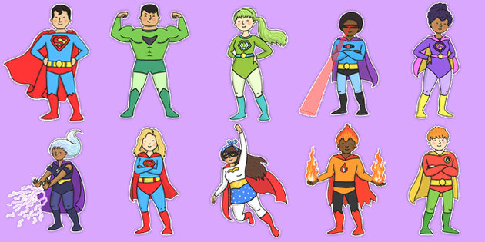

**General Reminders…**

* Woodland Warriors will continue on Thursday afternoons for half the class at a time.
* If you have any questions or concerns, please feel free to catch one of us or write a note in the reading record.
* A letter will be coming home in the next week about our upcoming Mr Egypt workshop- it promises to a fun filled day of hands on learning!

# Miss Hill & Mrs Nickless – Year 3 Pear & Oak

Welcome back! Thank you for all the lovely Christmas cards and gifts. Hopefully you have had a fun filled Christmas and are now ready for the term ahead. We have lots of exciting things planned for this half term as we begin our new topic of Ancient Egypt. We will also begin to learn songs for our Easter production – it will soon be upon us!

**PE in Year 3**

PE this term will continue to be on Wednesday and we will now begin our swimming lessons. Please remember children are only allowed goggles if you have signed the consent form.

The children will also have PE on Monday afternoons in Year 3 Pear and Thursday mornings in Year 3 Oak. This will be outdoors. As it is getting colder children may wish to wear dark coloured, plain joggers and a hoodie.

If children wear earrings they need to cover these with tape for each PE lesson.

If children use their PE kit for after school clubs please remember to bring it back the next day.

**Homework in Year 3**

We have been very impressed with the children’s enthusiasm for homework over the last term and we will keep to the same model. Homework will continue to be a choice of 1 activity a week based around our learning in class.

Reading records are generally being kept up to date. Please continue to read with your child, it is valuable for them to read out loud. We expect at least 3 comments a week in the reading record – either from yourself or the child.

Children still need to build upon their times table sknowledge. 3, 4 and 8s are the focus for Year 3.

Spellings are working well and we are seeing an improvement in written work. We will continue to send a list of 10 words home for learning. Please talk about the meaning of the words and their use; this will help the children to understand them fully.

**Spring term**

**Year 3!**