Year 4 Homework
Pick 1 activity to complete each week.
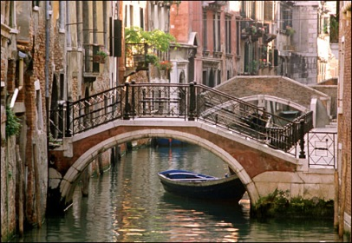  Design or make a bridge to go over one of the canals in Venice. | Spend half an hour on Times table Rock stars, Century or Education City. If you have not got your log in, please ask your teacher. | Find out some Italian words and design a phrase booklet for tourists traveling to Italy.  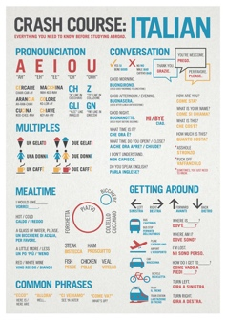
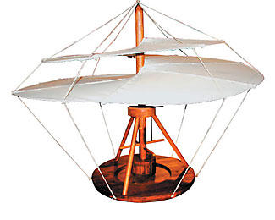  Look at Leonardo Di Vinci’s inventions. Draw an invention of your own. Explain what your invention is used for. | Make a savoury Italian pasta dish of your choice. Remember to bring photos in to show me! | 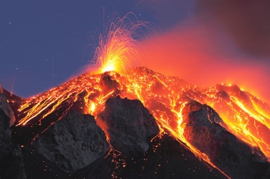  Carry out some research about a Volcano in Italy. Record your findings in an interesting way.
Hand in Dates:  Thursday 17th January  Thursday 24th January  Thursday 31st January  Thursday 7th February  Thursday 14th February | Find out information about one region of Italy. Write a fact file to show your findings. E.g. population, area, flag, weather etc. Include photos, pictures and writing.  