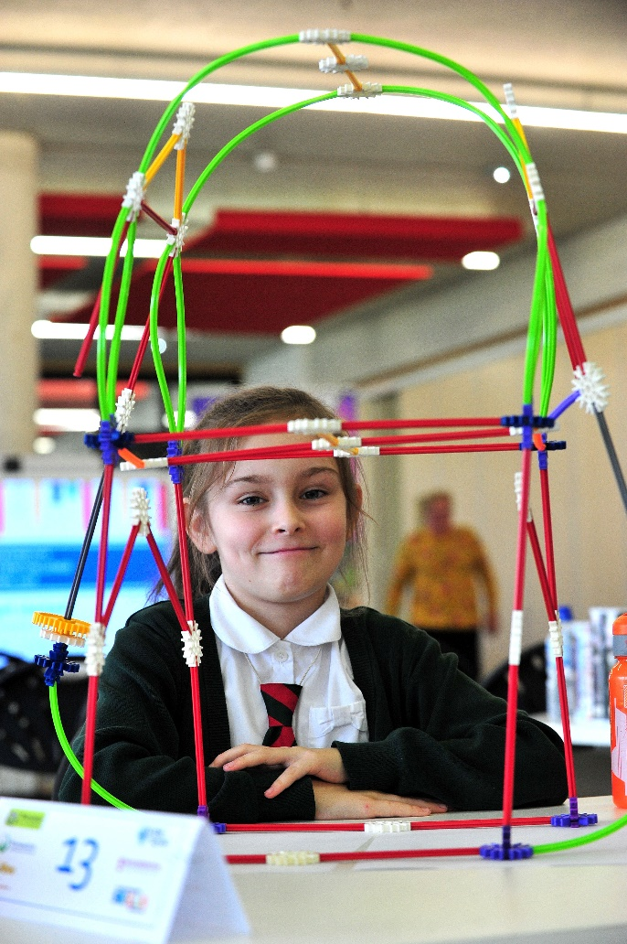
STEM CHALLENGE
By Lillyanne Videki
On Wednesday 7th February, members of Worcestershire City Council came in and explained that we would be designing a bridge to arch over the river at the bottom of Gheluvelt Park. We [year 4] had some K’nex and we tried to build our own bridge, this was extremely fun. Luckily, me [Lillyanne] and Gemma won! So then a couple weeks later we were told that since we won we got to go to the Hive for the final of the competition!
On Friday 16th March, me, Gemma and Mrs R went to the Hive! We had to build another bridge made out of K’nex but this time we had some new rules. We had a red rod and a red rod is the same height as a boat, we had to make sure people could walk on the bridge safely and that cyclists could travel safely too. We also had to make sure boats could go under the bridge. Instead of having a ramp or stairs that can move up or down, we made elevators! Me and Gemma were so excited but we didn’t win.
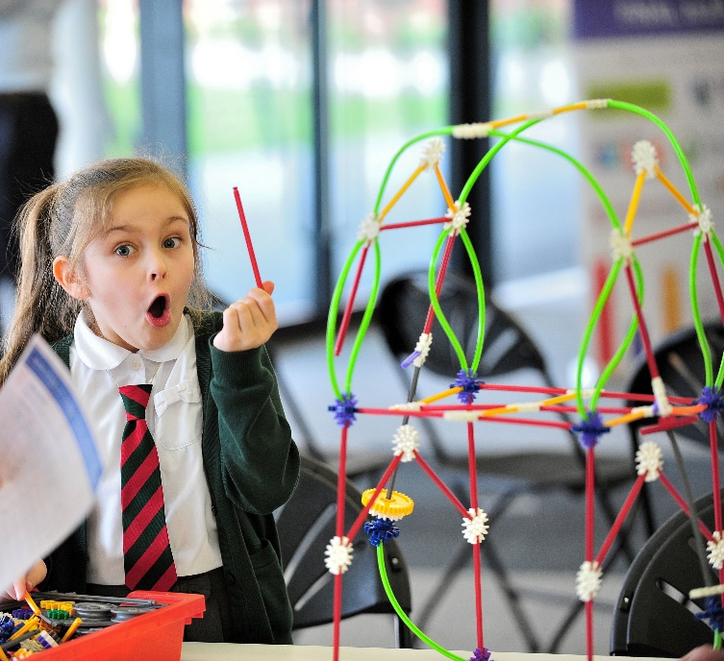
We were finalists and this made us feel very happy! It was fair for everyone because we all got a small prize! People who came 1st, 2nd or 3rd got a huge box of K’nex to take home and for their school. People who didn’t win or finalists [me and Gemma] got a small bag of K’nex to build at home!
