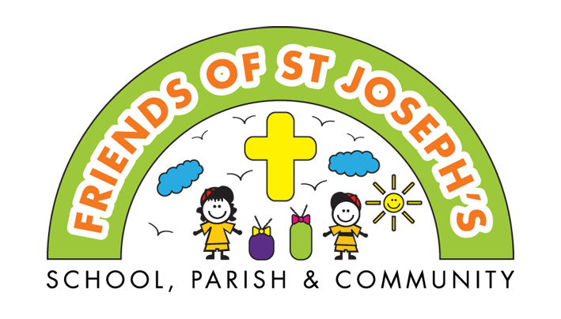

Nativity Rocks Movie Night
Please come and join your friends in the school hall to watch a movie.
Bring a pillow to sit on. Pyjamas optional.

Friday 6th December 6:15 – 8:45
Years 1 - 6 St. Joseph's pupils only

£4 per ticket, to include drink and snack, must be ordered in advance.

Please complete the form below and return it with the correct money in an envelope labelled 'Friends Movie night' by Wednesday 27th November.
We will enter all the children into the draw on the night to win the DVD.

Additional drinks & snacks will be available for 50p each during the interval.

Due to the numbers allowed in the hall, please can we ask parents not to stay unless you feel your child really needs you or for medical reasons.
No phones or toys please.
------------------------------------------------------------------------------

Child's name: | Class:

Drink order – please tick one |  |  | Snack order – please tick one
Water | Blackcurrant | Orange | Popcorn | Sweets

Signed consent to watch film: | Contact no:
Children will be expected to sit and enjoy the film, any children not wishing to do so will need to be collected. Thank you for your continued support.
This information will be kept for the duration of the event and shredded afterwards.

