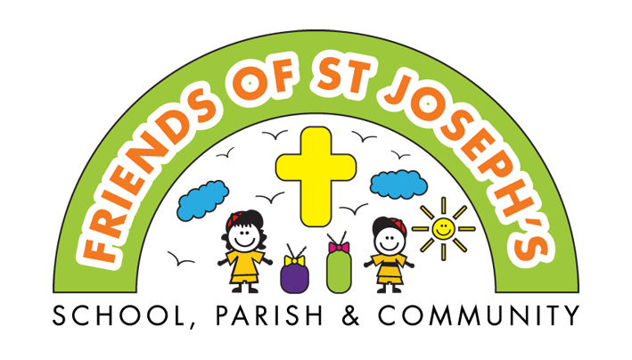
Christmas gift shop
Wednesday 4th & Thursday 5th December

Ladies and Men’s gifts priced at £5 each,including gift wrapping.

We are organising our Christmas shop for children to purchase gifts for the grown-ups in their family. The children will be taken to choose gifts during the school day. All gift are wrapped ready for Christmas.
If you would like your child to buy gifts, please complete the booking form below and return it with the correct money in an envelope clearly marked with 'Friends Christmas Shop' to the Friends postbox by office.

Please return by Monday 25th November

Thank you for your support.

----------------------------------------------------------------------------
Christmas gift shop

Child's name: | Class:
Ladies gift: | Men’s gift:

£ enclosed

