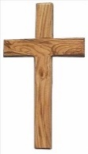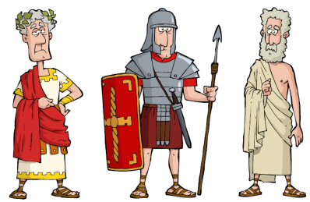

**ICT**

Using Purple Mash for

debugging, programming

& design. We will make

our own computer games!

**RE**

* Christmas
* Love and relationships curriculum
* The Church as a community
* Living as followers of Jesus
* Holy Week

**Prayers**

During Year 4 we will continue with our daily prayers (morning, lunch time & end of day prayers) plus we will learn the Magnificat and the Memorare.

**PE**

* Tri Golf & rugby
* A skills based session based on agility, balance, coordination and strength.

**Science**

**States of Matter**

Looking at the properties of solids, liquids and gases.

**Maths**

* Written methods of multiplying & dividing
* Length (including conversions)
* Fractions
* Decimals

Children will continue to complete weekly times table tests. Please continue to practice times tables at home to support the classroom learning.

**History & Geography**

We continue with the

Romans this half term.

We will look at the legacy

left by the Romans.

**Art and DT**

* Artist study – Leonardo Da Vinci
* We will re-create the famous Mona Lisa.

**Spring**

**Year 4**

**English**

* Handwriting.
* We will use the book Escape From Pompeii as our writing stimulus for the first half term.
* We will use non-fiction books.
* We will continue to focus on our spelling, punctuation and grammar.
* We will write for a variety of purposes including: letters, non-chronological reports, narratives and biographies.