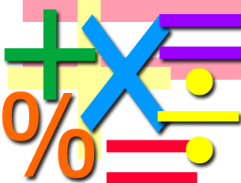

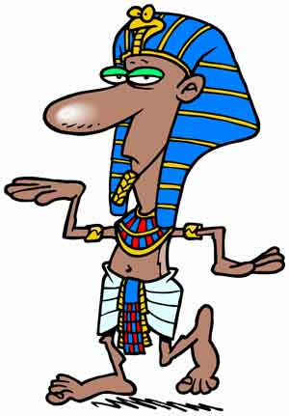

**History**

For history we will begin our topic of Ancient Egypt. We will continue this topic for the whole term as there is so much to learn!

We will be focusing on understanding where the Egyptians were in history and some key dates on their timeline. We will also look at artefacts from this time and what they teach us about this civilisation.

In Spring Two our focus will move to looking more closely at mummies and their tombs with a focus on Tutankhamun.

**Maths**

* Times tables - 3, 4, 8’s.
* Place value- we will revisit this alongside our fractions work to secure children’s understanding.
* Fractions of shapes and numbers, equivalent fractions, adding and subtracting fractions, comparing and ordering fractions, understanding tenths of a number.
* Problem solving activities will be linked to these areas.

Children will complete weekly times tables tests.

**ICT**

Working on improving word processing skills. We will also continue to work on our e – safety understanding.

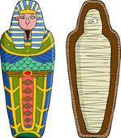 **DT**

We will link our DT this term to studying burial traditions throughout the ages and creating our own Sarcophagus.

**PE**

This term we will begin our weekly swimming lessons. Please remember to have swimming kits in school on Wednesdays.

Children will also learn to perfect their locomotor skills through a series of lessons focusing on jumping and running skills.

**RE**

**Christmas-** we will look at the Christmas story focussing on the experience of the shepherds.

**The Eucharist is a thanksgiving to God-** we will look at the communion part of Mass. This will link to our preparation for First Holy Communion.

**Lent-** we will focus on the Gospel stories about Jesus bringing change into the lives of other people.

**Holy week-** we will look at the links between the Last Supper and Mass.

**Science**

Rocks & Soils

We will compare and group together different kinds of rocks based on their appearance and simple physical properties. We will also look at how fossils are formed.

**Spring Term Year 3**

**English**

* Egyptian Cinderella will be our class book. We will use this to link to our topic of Ancient Egypt. We will use the story to base our English lessons on. We will look at:
  + Retelling the story focusing on speech marks.
  + Instruction writing
  + Letter writing
  + Diary writing
  + Non-chronological reports

We will continue weekly handwriting and spelling practice.