Thursday | English Lesson 09/07/20
Learning Objective | Write to Entertain
Prior Knowledge | - Prior learning in current year group.
Starter | 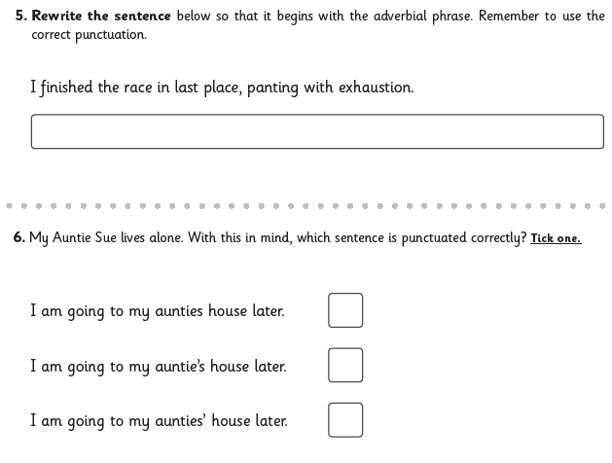Answers on the following page.
Main | Having nearly reached the end of the book. Can you take everything you’ve learned and write instructions for future Viking children on ‘How to Train Your Dragon’?  Read the PowerPoint presentation for tips on writing instructions.  There is an example which is annotated showing you what to include.  Think about:  - Heading and subheadings  - An introduction sentence  - An equipment list  - Steps in chronological (time) order  - Imperative (bossy) verbs  - Bullet points  - Adverbs, conjunctions and prepositions to show time  - A conclusion sentence  And remember to check your punctuation, spelling and capital letters!
Challenge | Edit and improve your writing
Starter Answers
