Below is a selection of activities linked to our learning. Please help your child to select one activity to complete each week. Homework books need to be in school by Thursday of each week (at the latest) to be marked and they will then be returned on Friday. If you have any questions or need to borrow anything to help you, please ask. Thank you for your support.
Extra homework ideas: Education City, Purple Mash, Times Tables Rockstars, Hit the Button (Top Marks)
Don’t forget spellings and reading!
Our first unit in RE is Christmas.  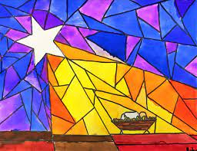  Create a piece of Nativity themed artwork!  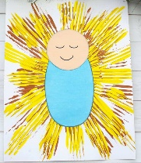 | In Maths, we will be looking at  Money. Create your own shop using items at home.  Label with £ or pence.  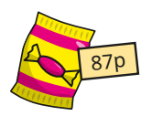 | In History we will be looking at how  school has changed over time. Do  some research to find out what  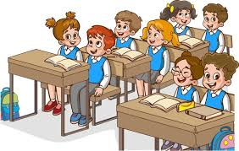  school was like in the 60s and 80s.
In English we are looking at the book  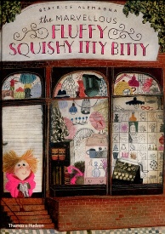  ‘The Marvellous Fluffy, Squishy, Itty Bitty’ by Beatrice Alemagna  Design your own imaginary creature and write some sentences or choose adjectives to describe it! | Our second unit in RE is special celebrations.  Can you find any photos or  artefacts of special events in  yours or your families lives?  For example baptisms or  weddings.  You can bring things into  school to share or upload  photos on Seesaw! | Play the Toy shop game on  Topmarks to practise your addition  skills! You can even choose single  coins to practise counting in 2s, 5s  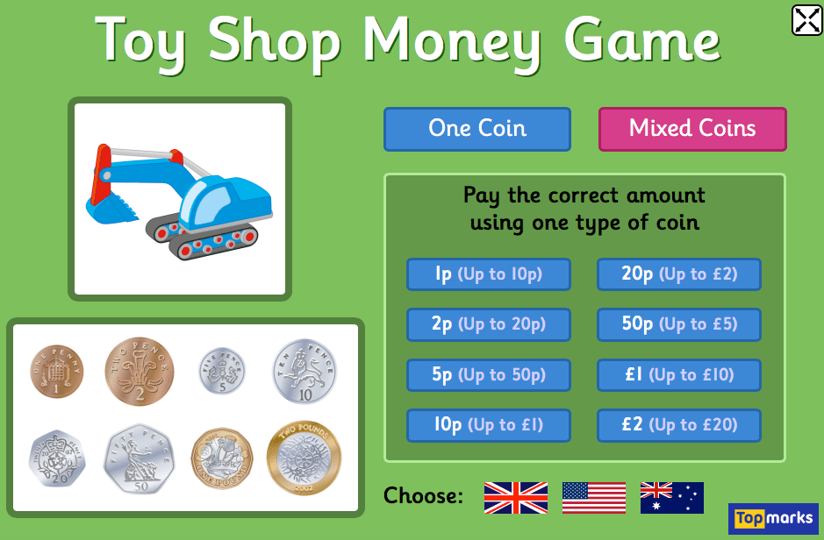  and 10s!
In science our unit is ‘Plants’.  Can you draw a diagram of a plant  And label its parts using scientific  vocabulary such as stem, leaves, roots etc.  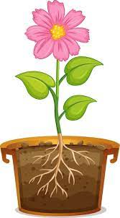 | Choose your favourite book  from home or school and write  some reading comprehension  questions based on the book. | Learn a playground game that would have been played by children in the 60s or 80s.  You can show the class how to play it!
Please remember to present your homework neatly and use a pencil when possible.

