

48 beads

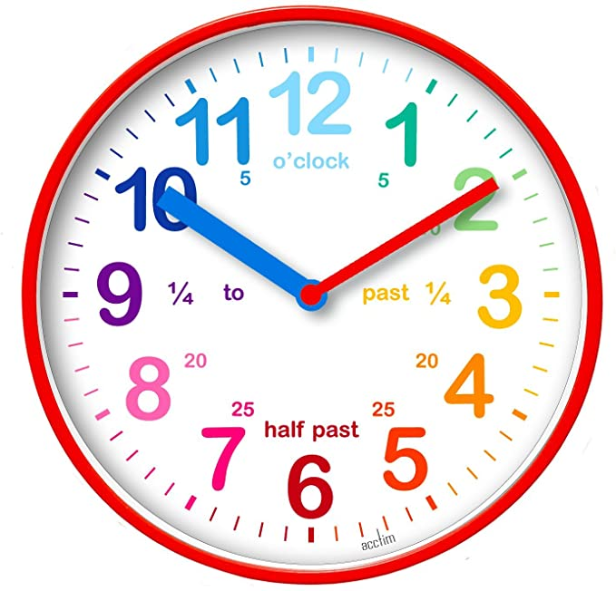

It is the number of hours in 2 days

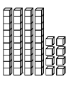

4 tens and 8 ones

It is half of 96

It’s an even number

What’s so great about 48?

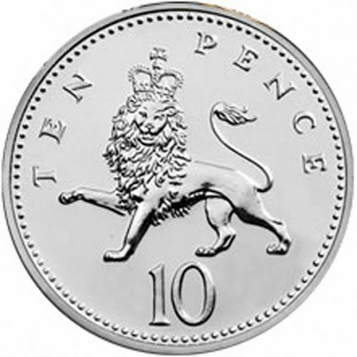

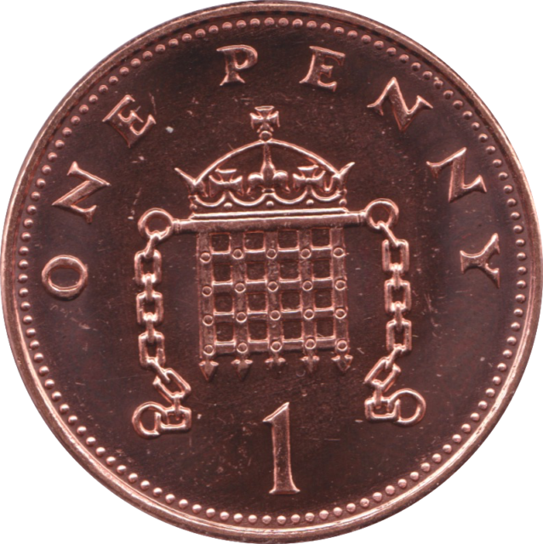

=48p

It is double 24

It is in the 1x, 2x, 3x, 4x, 6x, 8x, 12x, 16x, 24x and 48x tables

It comes between 47 and 49

It is 10 more than 38