Summer Reading Challenge
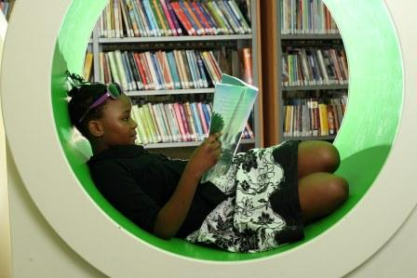
The Summer Reading Challenge, presented by The Reading Agency and funded by Arts Council England, encourages children aged 4 to 11 to set themselves a reading challenge to help prevent the summer reading 'dip'.
Each year the Challenge, delivered with the support of public libraries, motivates over 700,000 children to keep reading to build their skills and conﬁdence. Never has such support been needed than during the current lock down when the 'summer slide' is likely to have an additional impact on confidence and mental health for both children and parents alike.
This year, Silly Squad, the Summer Reading Challenge 2020, will celebrate funny books, happiness and laughter. Children taking part in the Challenge will join the Silly Squad, an adventurous team of animals who love to have a laugh and get stuck in to all different kinds of funny books!
The 2020 Challenge will feature bespoke artwork from award-winning children's author and illustrator Laura Ellen Anderson (Amelia Fang; Evil Emperor Penguin; I Don't Want Curly Hair).
The Silly Squad summer campaign will see us working with ambassadors to promote a new digital challenge platform to reach children across the nation. With children already at home, the 2020 Challenge will run from June to September, launching with a week of activity from Monday 1 June and culminating in an official launch day of curated events on Friday 5 June 2020.
Sign up at sillysquad.org.uk from Friday 5 June to join the Squad!

