**Communication and Language**

* Listening to a range of high quality texts
* Recalling past events and talking about them
* Daily Phonics (Groups set) – learning new sounds and consolidating
* Speech and Language activities
* Story Maps
* Signalong

**Physical Development**

* Wake up shake up/ Just Dance
* Fine motor activities – finger gym/dough disco
* Finger warm ups before writing
* Using effective pencil grip to form letters and numbers
* Selecting different tools
* Ball skills

**Personal, Social and Emotional Development**

* Zone board & Values and Virtues rewards discussions
* Talking about their emotions and co-operative play linked to Team Ant, introduce feelings zone.
* Looking closely at the characteristics of effective learning
* Talking about good choices and how we act these out at school

pppppppppppppppp

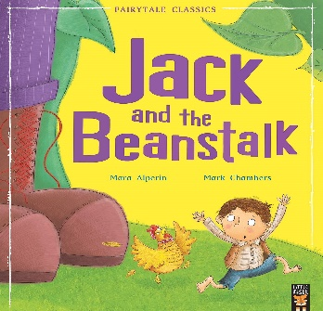

**The Early Years Foundation Stage**

**Spring 2**

**Understanding the World**

* Exploring changes in Little Leaves
* RE – Lent

**Mathematics**

* Subtraction
* Exploring teen numbers
* Weekly Mini Maths sessions
* Signalong Maths Vocab
* Maths challenges involving number and shape, space and measure
* Measuring using non-standard units
* Ordering size by capacity
* Exploring 3D shapes

**Expressive Arts and Design**

* RE crafts
* Mother’s Day crafts
* Acting out stories – re-enact scenes in role play area and small world
* EAD challenges in the environment

**Literacy**

* 1:1 reading to develop blending and segmenting skills
* Writing labels/captions/sentences
* Exploring text ‘Jack and the Beanstalk’
* Writing for different purposes
* Writing the first and last sound in words
* Continuing to sound out and blend words
* Literacy challenges
* Child initiated writing based on their interests in the environment